Using Panopto Lecture Capture

Before you start
You must be enrolled as a Teacher on the Canvas course you wish to record to.
You must enable Panopto in the Canvas course you wish to record to. You only need to do this once per Canvas course, but it must be done in order to store recordings.
You can check whether Panopto is enabled by looking in the left hand menu of the Canvas course for ‘Panopto’:
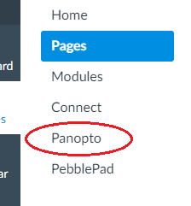
If Panopto is in the list, then you can record to that course. If it is not there, then follow the steps below.
(The Information Team enable Panopto in all courses they roll over so most Careers Network courses should be ok, however if your course is new, or is a personal or departmental one, then you may need to enable it, by following the steps below):
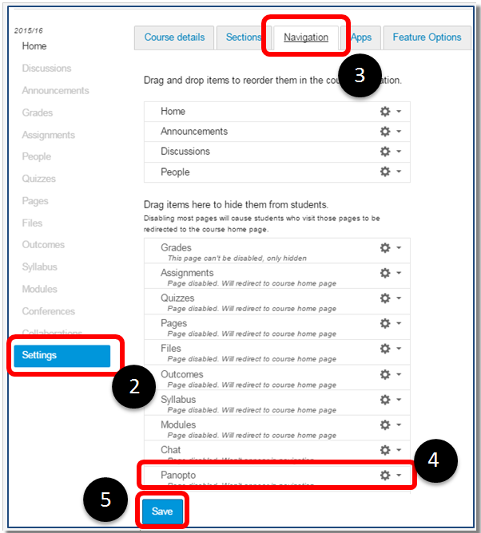

Step 1: Navigate to the Canvas course you want to use
Panopto in.

Step 2: Click on the Settings link in the Canvas course,
this is at the bottom of the Canvas left hand menu.

Step 3: Select the Navigation tab
Step 4: From the lower list of items, click on Panopto
and drag it in to the top list.

Step 5: Click Save. A tab called Panopto should now
appear in the course menu on the left.

Step 6: Click on the Panopto tab. This will create a
folder on the Panopto server.

Step 7: Once the folder has been created you can
record to it.

Recording
Step 1: On the desktop, click the Panopto icon. Alternatively, select Panopto from the Start menu.
Step 2: Click on Sign in with Canvas:
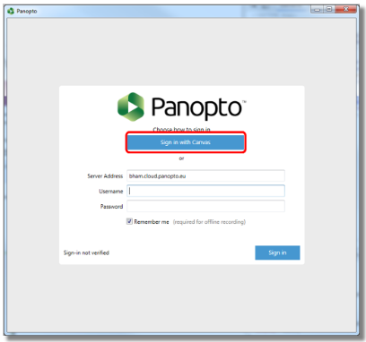
Step 3: Enter your university username and password, then click the blue Login button
Step 4: On the confirmation screen, click Login.
Step 5: The Panopto recorder window will appear.
Avoid clicking on the Panopto icon multiple times as it results in the recorder not launching. If this does happen simply close down Panopto and restart it.

Step 6: It is recommended that PowerPoint files are copied to and opened from the desktop of the machine, rather than being run from a USB memory stick or network drive when being used with Panopto – save these to the Desktop now.
Step 7: Back in Panopto, use the ‘Folder’ drop down menu to select which Canvas course to upload the recording to:
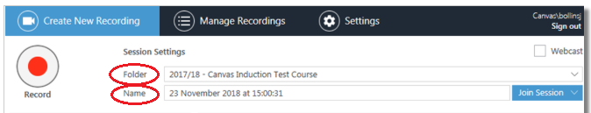
Step 7
Step 8
Step 8: Enter the title and date of the session in the ‘Name’ section.
Step 9: Under ‘Primary Sources’ select the following options:
Video None (unless you want to use the webcam, in which case select the webcam)
Audio Panopto mic or Boundary mic (whichever appears) (or select lapel microphone if the presenters are using the lapel mics)
Quality High
Do not tick the ‘Capture Computer Audio’ option.
Important: There must be at least one Primary Source selected in order for the recording to work, so do make sure the Audio is working. The Audio level is shown in the coloured bar; ideally the sound should be in the green area of the volume bars.
Step 10: If you are using a PowerPoint presentation, then tick the ‘Capture PowerPoint’ box under ‘Secondary Sources’. If you are not using a PowerPoint go to Step 16.
Do not tick the ‘Capture Main Screen’ option.
Step 11: Click on ‘Open a Presentation’ in the middle of the screen, and open the relevant presentation file (from where you have just saved it on the Desktop).
A ‘Begin recording’ box will appear – when ready select ‘Yes’ – your PowerPoint will open and recording will start automatically.
Step 12: Alternatively, you can click on the ‘Record’ button when you are ready, and then go to your PowerPoint.
If at any point during your session you wish to pause the recording, you can click the Pause button to temporarily pause the recording process. You can restart it when you are ready.
Step 13: Complete your presentation, navigating through the slides as necessary.
Step 14: When finished, exit the PowerPoint, navigate back to Panopto then click ‘Stop’ in the top left corner:
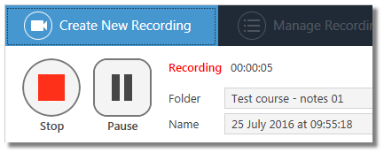

Step 15: Click ‘Upload’ on the confirmation screen and leave this to process:
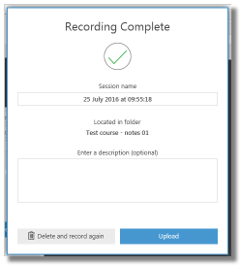
You can log out of the computer, but do not shut it down, as it needs to be on for the recording to upload.

Step 16: If you AREN’T using a PowerPoint, please do not tick ‘Capture PowerPoint’. If you have other files / resources / websites etc. that you will be using, you can select ‘Capture Main Screen’. If not, do not tick ‘Capture Main Screen’.
Step 17: When ready, click ‘Record’ in the top left corner, wait for Panopto to communicate with the server and then begin your presentation.
Step 18: When finished, click ‘Stop’ in the top left corner.
Step 19: Click ‘Upload’ and leave this to process. You can log out of the computer, but do not shut it down, as it needs to be on for the recording to upload.

If you have any problems in a centrally managed room when using Panopto then please contact the TAMU helpline on 43322, or via their email tamu@contacts.bham.ac.uk.

You can find more information about the different options and different things that can be captured, such as Main Screen or Whiteboard Capture, on the Canvas course by Birmingham Digital Education: https://canvas.bham.ac.uk/courses/18053/pages/unit-2-recording-additional-video-sources

Top Tips

- The use of the available lapel microphone is advised to ensure consistent high quality recording.
- Check lapel microphone battery before presentation. If low, please swap for spare battery (in charging dock). If both are low on battery or lapel microphone is unavailable, please use the table microphone (note you will have to select this option on the Panopto audio drop-down settings).
- If using the table microphone, try not to lean on the desk too much as this can cause sound disruption.
- Before starting the session, please advise the audience that the audio and slides will be recorded and made available on Panopto.
- If you are recording yourself (rather than a live workshop), make sure your chosen location is away from noise/building work, and where you won’t be disturbed. Consider putting a ‘recording in progress’ sign on the door. Be aware that the Terrace Huts can sound quite echo-y, and that sound bounces around the Employer Training Room.

Useful links:
Copying and moving recordings: https://canvas.bham.ac.uk/courses/18053/pages/unit-4-copying-and-moving-recordings
Editing recordings: It is recommended not to spend time editing, but instructions on editing can be found here: https://canvas.bham.ac.uk/courses/18053/pages/unit-6-editing
Analytics: The Panopto tab on your course provides statistics not only for the number of views and hits on the folder, but also individual recordings and what part of the session is viewed most frequently. This is accessed by hovering over the recording and clicking on the statistics icon. More information on this can be found here: https://canvas.bham.ac.uk/courses/18053/pages/unit-5-using-statistics-and-analytics
Panopto Canvas course, from Birmingham Digital Education: https://canvas.bham.ac.uk/courses/18053

Legal requirements
Please be aware there are legal requirements with using Panopto, including the Code of Practice and conditions for external presenters:
Informing the students
Tutors must ensure that students know that a session is being recorded. HEFi recommend that you include a slide stating this at the start of your lecture, and use this as a reminder to tell your students "This session is being recorded".
Third-party consent
If a significant contribution is made to a recording by a student, or an external (non-UoB staff) speaker, then a signed consent form must be obtained before the recording can be published. The form is available on the Panopto Canvas course: https://canvas.bham.ac.uk/courses/18053/files/6205621/
Completed forms should either be scanned and emailed to HEFi at hefi-enquiries@contacts.bham.ac.uk, or a hard copy sent to HEFi Admin, 2nd Floor, Old Gym.

A significant contribution would be anything more than answering a question or contributing to a discussion, for example making a presentation.
You can find more legal information about using Panopto on the Panopto Canvas course page: https://canvas.bham.ac.uk/courses/18053/pages/unit-3-legal-conditions

Acknowledgment
Some content on this handout has been adapted from the Birmingham Digital Education Canvas course on ‘Event Capture with Panopto’: https://canvas.bham.ac.uk/courses/18053 (Accessed: 08/01/19)

