VAT
NOTES FOR END USERS PURCHASING ITEMS RELATING TO VAT RECOVERABLE RESEARCH PROJECTS
Categories of Research where VAT is Recoverable on Purchases/Associated Costs
Typically, where a research project is funded by an industrial or a commercial funder – whether they are based in the UK or elsewhere – the income is either VATable in the UK or would be VATable if it were charged in the UK. As a result, VAT is recoverable on costs:
UK Industry, Commerce & Corporations | UK VAT recoverable
EU Industry, Commerce and Corporations | UK VAT recoverable
Non EU Industry, Commerce and Corporations | UK VAT recoverable

If you are in doubt whether your project is a VAT recoverable project, then please refer to your contact in Research Finance, Research Contracts or the output of the KPMG Research Liability Tool for your project.
Oracle Process for selecting VAT Recovery on Requisitions
End Users will go through the requisition process to identify the item that they wish to purchase and will add the item to their cart.
Once the End User gets to the View Cart part of the requisition, the following screen will appear;
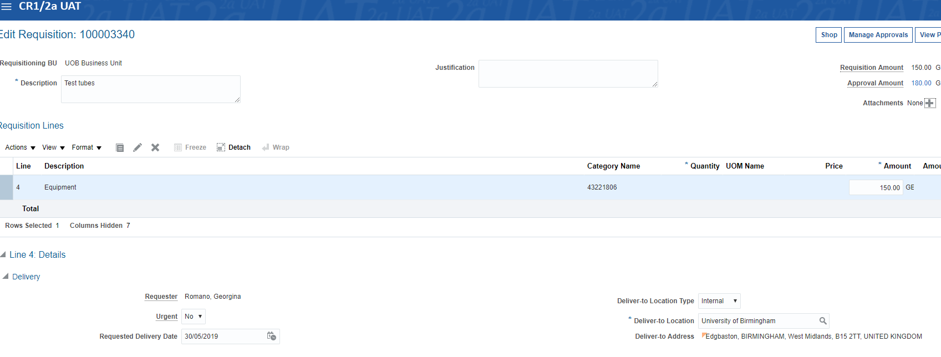
The approval amount will usually show VAT (assuming the item is usually Standard Rated).

If the End User considers that the project is VAT recoverable (as set out above or based on advice), then they will scroll down to the following box towards the bottom of the screen:
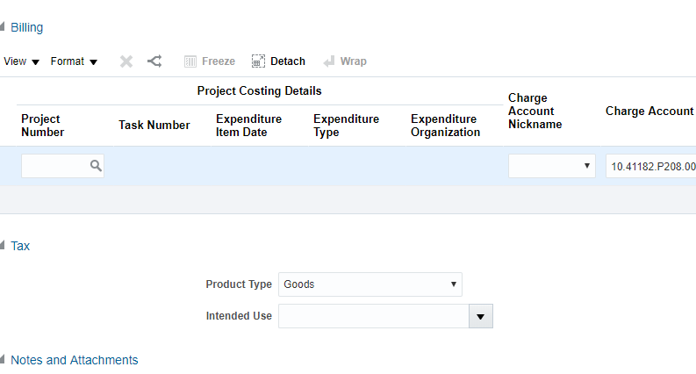
Under the Intended Use box – the User must select the Drop down option “RECOVERABLE - UK INDUSTRY” – please note, this will apply to all VAT recoverable projects including EU and non EU industrial funded projects.
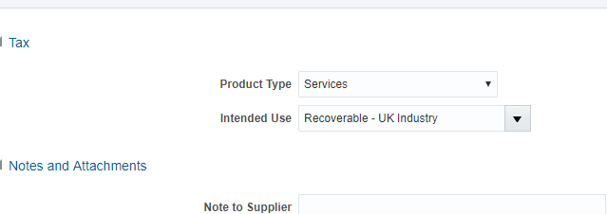

The End User will then need to return to the top of the screen and click “Calculate Amount with Tax” in the Approval Amount box;
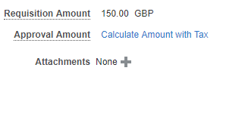
Once this is clicked, the tax should be recalculated as recoverable and the Approval Amount for the budget holder should be the net amount of the item as shown below;
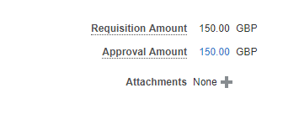
Where to go for advice?
If in doubt about the recoverability of a research project or the process of ensuring that VAT on costs does not hit your project account, End Users should contact their Approver in the first instance or their usual Research Finance contact.

End Users may also contact the VAT Helpdesk for further guidance as below;
Vathelpdesk@contacts.bham.ac.uk

