# **Buzz 190: April/May 2021**

# **Inside:**

# **Unfiltered Lives: autism education**

# **SCRUM: concussion in rugby**

# **Grow with Joe compost bins**

**Welcome**

Hello and welcome to this April/May edition of Buzz magazine. A lot has changed over the past couple of months, with the vaccination roll out continuing at pace, restrictions beginning to ease and some warmer weather finally arriving.

It’s been a real pleasure to share some of the great work that’s been taking place over the past year, and the pandemic forcing the switching of Buzz to a digital channel has allowed us to be a bit more creative in the way we tell these stories.

Some of you will no doubt be thinking about returning to campus soon; I'm sure that there are mixed feelings around this. Some will be looking forward to returning, while others may be feeling anxious or concerned about going back to things as they were before covid arrived.

One of the things I think we’d do well to learn from this period is to appreciate our individual and collective strengths and weaknesses, and how our diversity of talent and personalities can flourish under very different circumstances and work environments.

How we communicate, receive and respond to messages is also really important, and so we’ll be thinking about how we deliver Buzz going forward, digitally or in printed form, or in some combination of the two. Whatever we do, we want to make sure that staff are getting the most value from the publication, so if you have any thoughts or ideas on this then please get in touch.

Thank you

Matthew Collins, Editor

**Latest events online**

You can catch up on the latest staff events on the University intranet pages.

**Vice-Chancellor’s Forum. Professor Sir David Eastwood In conversation with Kathryn Stanczyszyn (BBC News). 11 February 2021.**

Look back on the VC’s Forum in February, where Kathryn Stanczyszyn from the BBC asked the Vice-Chancellor about the latest challenges posed by COVID-19 and how the University is supporting students. You’ll also hear about sector developments, REF and TEF and how the University is widening access and delivering our new Equality Strategy.

[Catch up here](https://intranet.birmingham.ac.uk/staff/intcomms/vice-chancellors-online-forum.aspx)

**Birmingham Professional Forum. 2 March 2021**

We were delighted to be joined by Dr Sarah Forbes who introduced the Working from Home during COVID-19 Lockdown Project, and by Deputy Pro-Vice-Chancellor for Equality, Diversity and Inclusion, Professor Jo Duberley who outlined the new EDI Scheme and Equality Change Programme.

Director of External Relations, Cathy Gilbert was joined by Jess Harrington from the University’s Birmingham 2022 Commonwealth Games project team to provide an update on our campaign plans for the Games, and Katy Leighfield and Mark Smith talked through the latest IT developments.

[Catch up here](https://intranet.birmingham.ac.uk/staff/intcomms/birmingham-professional-online-forum.aspx).

**Grow with Joe**

New community compost bins have been installed in the Green Heart community garden. The ‘Grow with Joe’ garden aims to not only become more sustainable but to satisfy the need for quality compost.

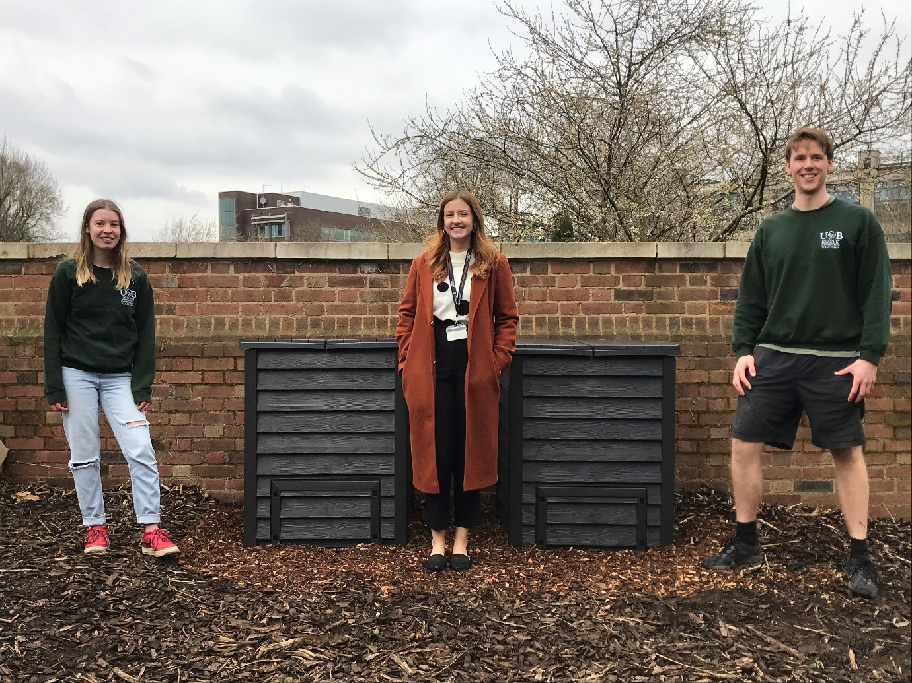

*Conservation volunteers with Jade Willetts environmental officer, centre*

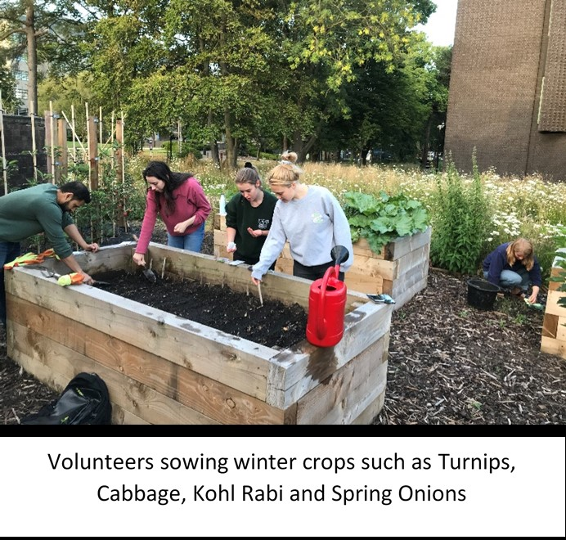

*Volunteers sowing winter crops such as turnips, cabbage, kohl rabi and spring onions*

The ‘Grow with Joe’ garden is run by student volunteers from the Conservation Volunteers Society and is now in its third year of production in the heart of campus. The garden project was established to encourage students, staff and members of the wider community to become interested in local food production.

The new insulated compost bins, funded by Campus Services, will provide a clean receiver for staff and students to deposit their organic food waste, such as vegetable peelings, egg shells and biodegradable tea bags. The main aim is to teach members of the community about organic food and its benefits, to reduce waste from students and staff and to make the project more self-sustaining and less reliant on external input.

**Allowed in the compost is:**

Fruit/Vegetable Peelings

Egg Shells

Biodegradable tea bags

Coffee grounds

**Not allowed in the compost is:**

Plastic, of any kind

Meat, fish, dairy or oils

Diseased plant material

On-going maintenance of the project will be managed by staff and student volunteers from the Conservation Society.

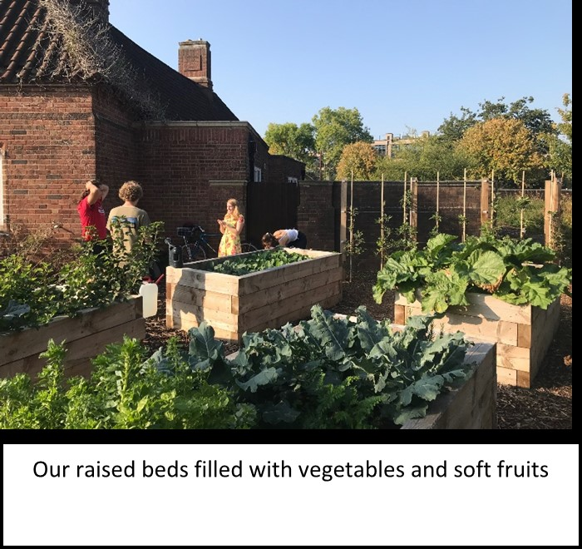

*Our raised beds filled with vegetables and soft fruits*

**Lawrence Weston, of the University of Birmingham Conservation Volunteers,** said: *“We are really grateful to the University and the Guild of Students for their support with the new community composting initiative. The bins give us an opportunity to introduce new people to our garden, as well as give us a fresh supply of compost to grow fresh fruits and vegetables.”*



*BUCV logo*

**Equality, Diversity and Inclusion**

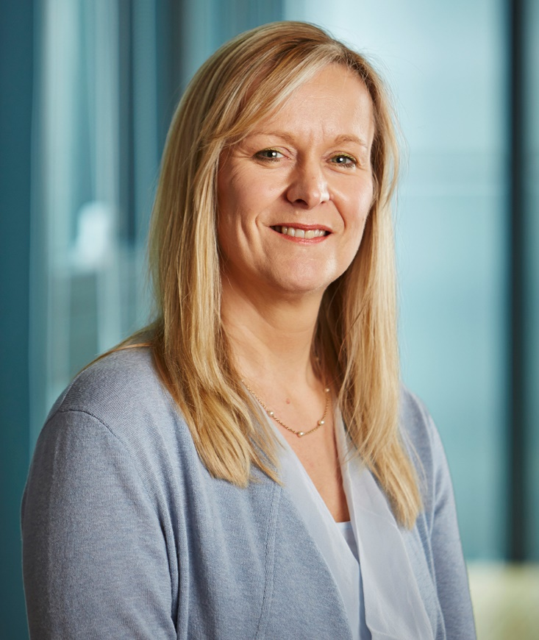

Welcome to our latest round up of Equality, Diversity and Inclusion (EDI) news. When we were developing the new Equality Scheme, a common piece of feedback was that we need to do more to tell staff about the work that we are doing. In this edition we are sharing news about Working Families initiative, updating on plans for Birmingham PRIDE and the National Day of Staff Networks and highlighting work taking place in MDS and our Branching Out events.

We have also redeveloped our [EDI website](https://intranet.birmingham.ac.uk/collaboration/equality/index.aspx) as a central part of the new Equality Strategy. The new website provides information and resources to support staff and student equality work and I encourage everyone to have a look at what is on offer. Finally, there is a spotlight on the central EDI team.

I hope you are enjoying our new EDI pages. Do get in touch with the team at [equality@contacts.bham.ac.uk](mailto:equality@contacts.bham.ac.uk) with any queries, questions or suggestions.

Best wishes,

Jo.

**Celebrate the National Day of Staff Networks - Wednesday 12 May**

The National Day of Staff Networks was set up five years ago to celebrate the work that Staff Networks do to make UK workplaces more inclusive. The University supports [five staff networks](https://intranet.birmingham.ac.uk/collaboration/equality/staff/staff-networks/index.aspx) who work with the Equality Team to deliver the equality strategy; increasing engagement with groups of staff who traditionally face barriers in the workplace. Find out more about the [National Day of Staff Networks](https://www.nationaldayforstaffnetworks.co.uk/) or join our [University celebration event](https://www.eventbrite.co.uk/e/143753950937).

**Birmingham PRIDE update**

Birmingham PRIDE has been moved from May and will be taking place this year in September. Once again Staff and Student Networks, Students Services, DARO and HR will be working together to represent the University. If you are joining in the fun, don’t forget to come and say hello.

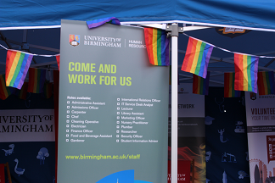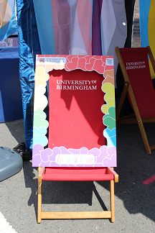

**Working Families**

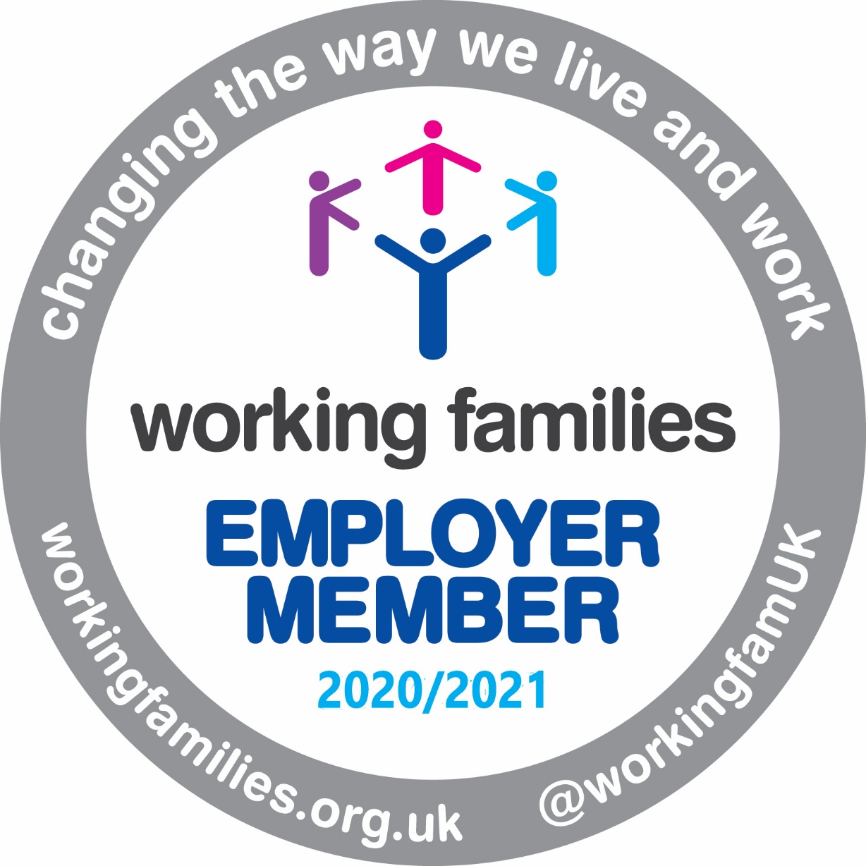

The University has joined Working Families a specialist work-life balance charity. This was recommended in the University Athena action plan and will give us access to a wealth of research and resources to support our flexible working initiatives.

**College spotlight: MDS**

[3 photos to follow. 0436 Bring your family to work day, 0999 the EDI committee and “twitter” a picture from Bring Your family to work day.] Please can you leave space for this?

The MDS EDI Committee‘s remit is to ensure staff and students feel the College is an inclusive environment where they can progress throughout their careers/studies and reach their full potential. We have EDI Leads across our Institutes and Professional Services who are responsible for driving cultural change across the college and acting as points of contact for EDI-related queries. As a group we have worked hard to change the perception that EDI within MDS is only about Athena SWAN, but we are very proud of our 2020 Silver award!

Formed in late 2018, an early action was to run a staff EDI survey to identify priority areas. The Committee has produced guidance on supporting academic promotion applicants (including introducing Career Development Leads), produced a range of EDI leaflets for line managers and staff as a one-stop source of support (most recently on menopause), introduced mandatory Equality Impact Assessments to College Board paperwork, and relaunched a Parent and Carers fund to support attendance at conferences/training/external panels. We also run and support EDI events and activities including Bring Your Family to Work Day.

**Branching Out**

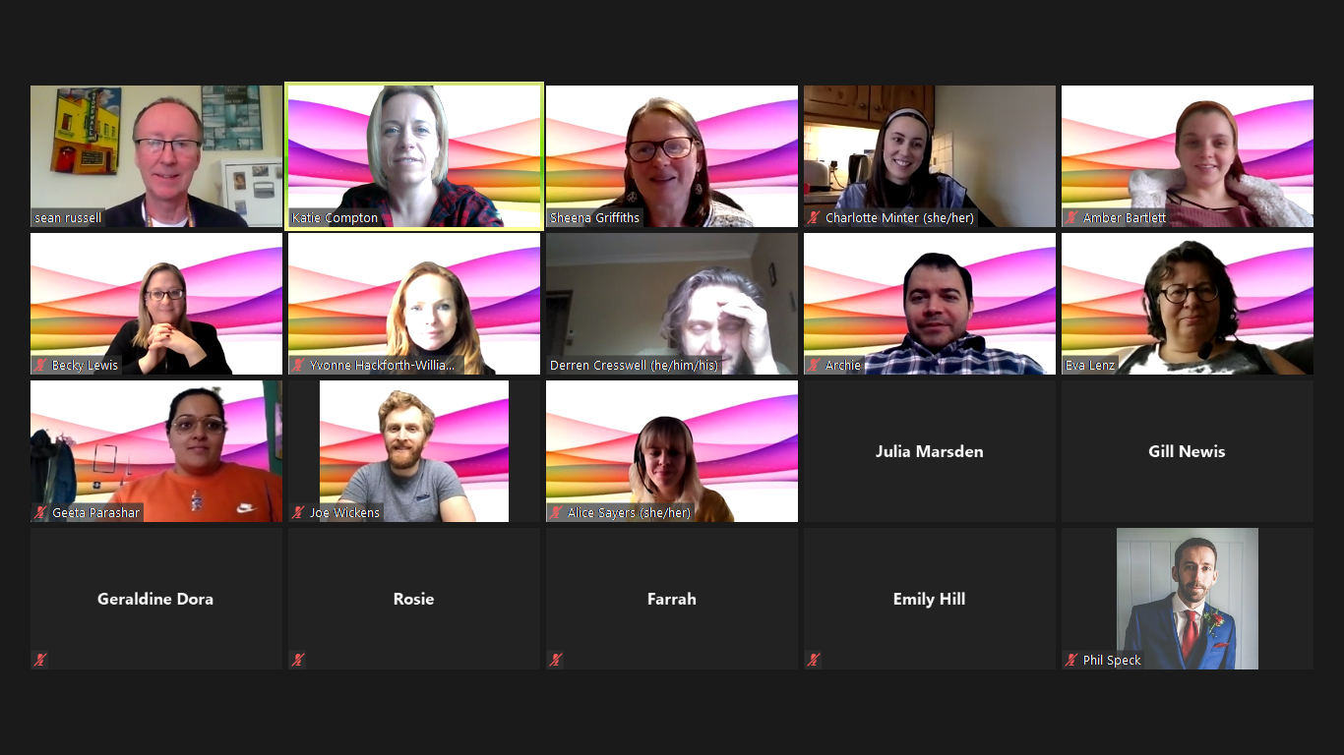

‘Branching Out’ events are run by HR on behalf of the staff networks. The events run monthly for 30 minutes and aim to be fun, friendly and informative. February’s event celebrated LGBTQ+ History Month with a bingo style quiz. For more information see our [Branching Out webpage](https://intranet.birmingham.ac.uk/collaboration/equality/staff/staff-networks/branching-out.aspx).

**Parents and Carers Fortnight**

The University will host its first Parents and Carers Fortnight from 1 to 13 June. There will be a range of events, coordinated by the Parents and Carers Staff Network, to mark Global Day of Parents and Carers Week, including a virtual experience of living with dementia. The full range of events is on the Parents and Carers Network in Teams (join code: mpucara), or email [parentsandcarers@contacts.bham.ac.uk](mailto:parentsandcarers@contacts.bham.ac.uk).

If anyone would like to get involved and arrange an event to mark Parents and Carers fortnight, please to get in touch with [Katie Compton](mailto:K.E.compton@bham.ac.uk) in HR for an events submission form.

**Meet the central EDI team** (2 photos attached and 1 to follow)

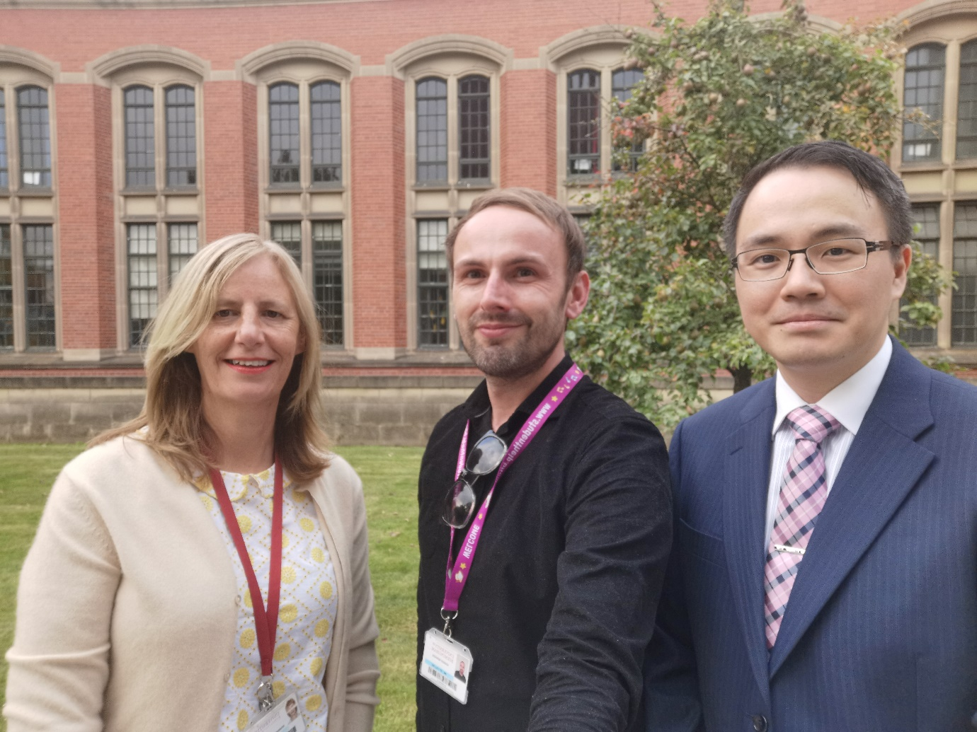

*Sue Onens, Sammy Li and Pete Collins in Student Services*



*Sheena Griffiths*

The central EDI team comprises Susan Squire and Sheena Griffiths based in HR and Sue Onens, Sammy Li and Pete Collins in Student Services. The team supports Jo Duberley in developing, delivering and evaluating the Equality Strategy, oversees University wide initiatives such as Athena SWAN, Stonewall and the Race Equality Charter and works in partnership with individuals and teams across the University to embed EDI initiatives. The team are always happy to talk about EDI. If you are not sure who to contact, you can get in touch via our generic email address: [equality@contacts.bham.ac.uk](mailto:equality@contacts.bham.ac.uk)

# **Unfiltered Lives: Sharing the stories of autistic children, young people and their families to advance inclusive attitudes**

In the latest Unfiltered Lives we meet three wonderful families who have taken the time to share their experiences of lockdown, insight into their school lives as well as their hopes and aspirations for the future.

## **Research helping to support autistic pupils in the classroom**

There are over 120,000 autistic pupils in England’s schools, of which more than 70% are educated in mainstream schools. In England, autistic children and young people (CYP) are more likely to be regularly and unlawfully excluded from school for a fixed period than children who do not have special educational needs.

Researchers at the University of Birmingham, led by Director of the Autism Centre for Education and Research (ACER), Professor Karen Guldberg have made substantial contributions to developing autism education founded on both the knowledge base of research and practice. This research continues to challenge the misconceptions around autism.

ACER have empowered teachers to see autistic CYP as having different and distinct learning needs, rather than being ‘problematic’. Through extensive research we now have an advanced understanding on how autistic people learn and ways in which teachers and senior leaders can demonstrate inclusive attitudes and pupil-centred approaches which will transform the educational experience of autistic pupils.

## **Meet Terri and Sophie**



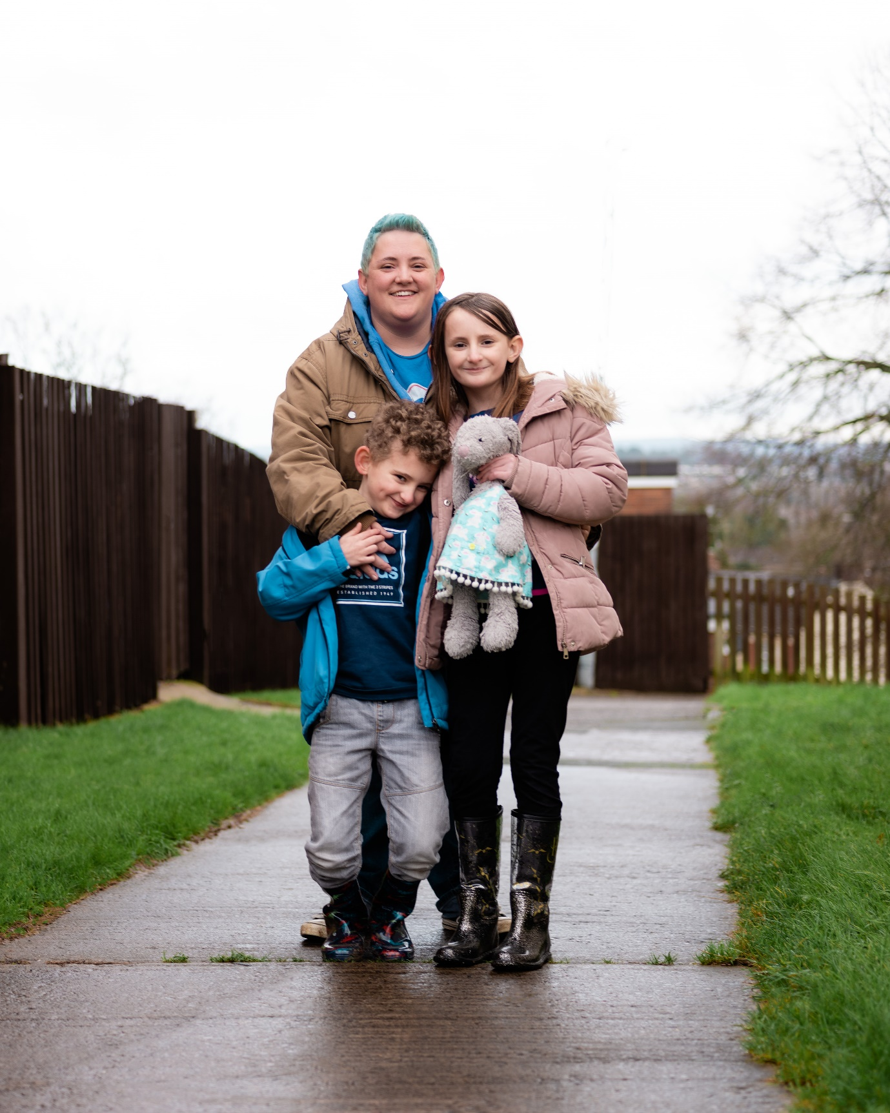

Terri is a primary school classroom assistant in south Wales and has been for the past 12 years. She lives with her husband and two children, Sophie aged 10 and James aged 6. In 2016 Terri’s daughter Sophie was diagnosed as being on the autism spectrum.

Terri is passionate about research, she not only values its importance but over the years has taken the opportunity for her and Sophie to be involved, with the consideration that “*five minutes out of my time could change someone’s life in the future*.”

When chatting with Terri she said, “*People assume that once you have a diagnosis you’re all sorted and you have all the help you need. But that’s just not true! They say being autistic is a spectrum of needs, but often people make the same assumptions about everyone with autism - yet everyone I’ve met with a diagnosis has been different*.”

Terri has confidence that society and people’s view around autism are changing for the better. She said: “*Some people are afraid of the label and the stigma, but for us, being able to explain to Sophie that it’s okay to feel the way she does, or that her response to something is normal for someone with autism was a massive boost in confidence for her! Suddenly she had an answer to why she wasn’t like everyone else.”*

## **Meet Shardia and Patrick**





Mum Shardia and her family love exploring the great outdoors. Patrick III, the eldest of her two sons, “…*is the most fun-loving, cuddly, innocent young person you could ever meet*.” In 2019 Patrick was diagnosed as being on the autistic spectrum and is now attending a new school which has made huge improvements to his education and enjoyment of being in the classroom.

Patrick has always had a challenging time in educational settings, mainly due to him displaying behaviours of being autistic but not having a diagnosis until he was 6 years old. Shardia reflects “*that milestones such as making friends, joining in with extra-curricular activities and general school achievements were difficult to say the least.”* But things have improved dramatically for Patrick over the past 12 months. Shardia and Dad, Patrick Jnr, made the decision to take him out of private school and place him in a local state school. Since then, they have been involved in applying for an Education, Health and Care plan (EHCP) and have regular communication with the SENCO from the school. An EHCP is important as it identifies a child’s or young person’s special needs and sets out the support needed to meet those needs.

The desire to share experiences and give a voice to parents, carers and those individuals with autism is clearly very important to Shardia and her family. From lived experience she explains how: “*it’s common that autistic children and young people are spoken for and often about*”. A change she would like to see from policy-makers and those in the education sector is to involve individuals and families in discussions and decisions from the beginning.

## **Meet Wendy and Sam**

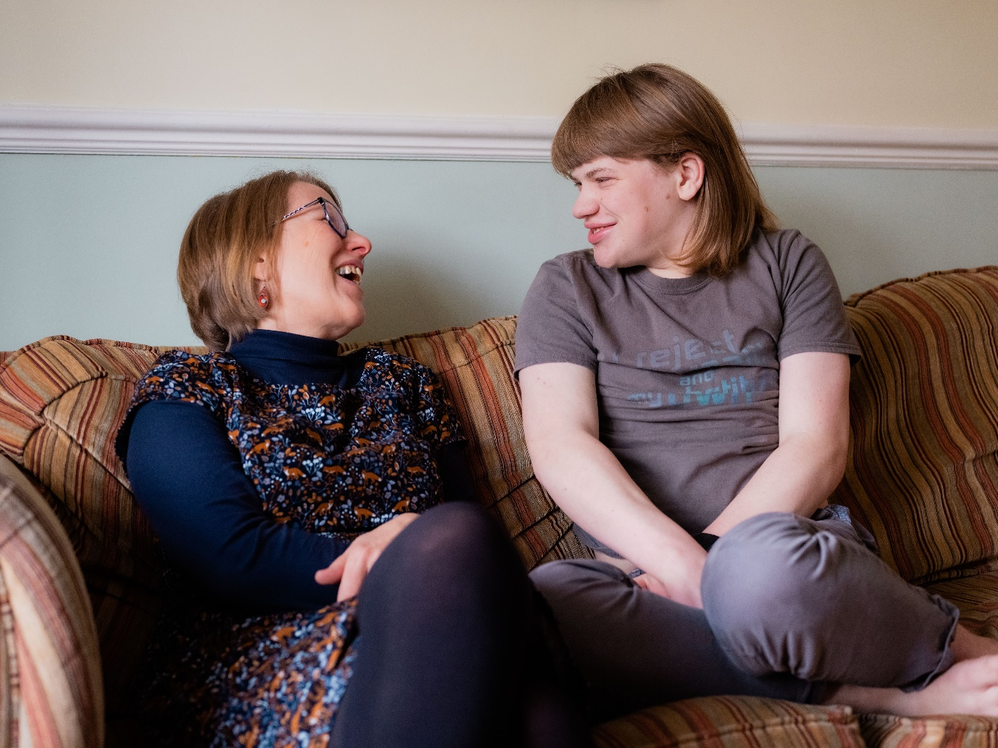



Sam is 19 years old, he attends College and lives with his Mum and Dad, Wendy and Tim. Like many other young people, having independence is important to Sam and he has clear dreams and aspirations for the future: “*I want to have friends and make films. I am not sure if I want to make films as a job or as a hobby, but I would like a job to help pay for things*.”

When Sam was diagnosed with autism, mum, Wendy began developing her knowledge of autism by attending various talks and conferences. Today, Wendy proudly admits that learning about autism has become her passion and her purpose. Wendy talks openly about why it is key to give autistic children support from an early age and believes that by doing this “*we can enable people with autism to live fulfilling lives and be able to access their communities successfully*.”

The importance of autistic people gaining independence is echoed in Wendy’s thoughts on the necessity for research; “*research into things which can successfully support autistic individuals helps me to support Sam better and to reach our goal of him living a full and independent life*.”

As Wendy works professionally in the field of autism education and it has shaped her family life we asked what advice she would give to other parents to best support their autistic child, with clarity and eloquence she said: “*help your child to feel loved and secure for who they are, whatever is going on around them, because they are amazing!*”

**Read their full stories at** [**Unfiltered Lives**](http://www.birmingham.ac.uk/unfiltered-lives).

**Rugby SCRUM study identifies new method to diagnose concussion using saliva**

A University-led study of top-flight UK rugby players - carried out in collaboration with the Rugby Football Union (RFU), Premiership Rugby, and Marker Diagnostics - has identified a method of accurately diagnosing concussion using saliva, paving the way for the first non-invasive clinical test for concussion for use in sport and other settings.

Following the team’s previous [research](https://pubmed.ncbi.nlm.nih.gov/28279125/), which identified that the concentration of specific molecules in saliva changes rapidly after a traumatic brain injury, the researchers embarked on a three-year study in elite rugby to establish if these ‘biomarkers’ could be used as a diagnostic test for sport-related concussion.

Using DNA sequencing technology in the laboratory at the University, the research team tested these biomarkers in saliva samples from 1,028 professional men’s rugby players competing in English rugby’s top two leagues - the Premiership and Championship.

The results of SCRUM (Study of Concussion in Rugby Union through MicroRNAs), published in the *British Journal of Sports Medicine*, has for the first time shown that specific salivary biomarkers can be used to indicate if a player has been concussed. Additionally, the research has found these biomarkers provide further insights into the body’s response to injury as it evolves from immediately after trauma, to several hours and even days later.

The scientific breakthrough provides a new laboratory-based non-invasive salivary biological concussion test, which could have wide-reaching use and potential to reduce the risk of missing concussions not only in sport – from grassroots to professional levels – but also in wider settings such as military and healthcare.

In community sport, these biomarkers may provide a diagnostic test that is comparable in accuracy to the level of assessment available in a professional sport setting. While, at an elite level of rugby, the concussion test may be used in addition to the existing World Rugby Head Injury Assessment (HIA) protocol.

Marker Diagnostics, a subsidiary of Swiss biotechnology company Marker AG, is in the process of commercialising the patented salivary concussion test as an over-the-counter test for elite male athletes. It has also obtained a CE Mark for test, which has been named MDx.100.

The team now aims to collect further samples from players in two elite men’s rugby competitions in order to provide additional data to expand the test and develop its use to guide the prognosis and safe return to play after concussion and to further establish how it will work alongside the HIA process.

The team will present their findings and planned next research steps at the World Rugby Laws and Welfare Symposium.

Meanwhile, Marker Diagnostics and the University are currently carrying out several additional studies to further validate and expand the test for use in different groups that were not included in the SCRUM study, including women, young athletes and community sports players.

The research is part of the [REpetitive COncussion in Sport (ReCoS)](https://srmrc.nihr.ac.uk/trials/recos/) research programme being led by the University through the National Institute for Health Research’s Surgical Reconstruction and Microbiology Research Centre (NIHR SRMRC) based at University Hospitals Birmingham NHS Foundation Trust (UHB).

First author **Dr Valentina Di Pietro, of the University of Birmingham and NIHR SRMRC**, said: “Concussion can be difficult to diagnose, particularly in settings such as grass roots sports where evaluation by a specialist clinician is not possible. Consequently, some concussions may go undiagnosed.

“There are also concerns regarding the long-term brain health of those exposed to repeated concussions.

“A non-invasive and accurate diagnostic test using saliva is a real game changer and may provide an invaluable tool to help clinicians diagnose concussions more consistently and accurately.

“In professional sports, this diagnostic tool may be used in addition to current head injury assessment protocols and return to play evaluation to ensure the safety of individuals."

Senior author **Antonio Belli, Professor of Trauma Neurosurgery at the University of Birmingham, Consultant Neurosurgeon at UHB, and Director of NIHR SRMRC**, added: “Conducting a study in a professional contact sports setting has meant we have been able to collect invaluable data enabling us to make significant advances in our biological knowledge and understanding of concussion and its diagnosis.

“Crucially, the differences in the salivary concentration of these biomarkers are measurable within minutes of injury, which means we can make rapid diagnoses.

“The ability to rapidly diagnose concussion using biomarkers in addition to existing tools solves a major unmet need in the sporting world as well as in military and healthcare settings, particularly in injuries without significant visible symptoms.”

To find out more on this study, [please visit the website.](https://www.birmingham.ac.uk/partners/enterprise/news/latest/rugby-study-identifies-new-method-to-diagnose-concussion-using-saliva.aspx)

# **I’m a partner, a relative, a friend…a carer?**

Whether you identify as a carer or have someone close to you who does, at the Parent and Carers Staff Network, we welcome you to contact us at [parentsandcarers@contacts.bham.ac.uk](mailto:parentsandcarers@contacts.bham.ac.uk) and join the conversation about how we can all support those with caring responsibilities better.

Most people think of carers as not working and providing 24 hours care for a loved one in their household. Therefore, if staff don’t fit this narrow profile, they don’t identify themselves as carers and then their needs remain unsupported.

Birmingham Carer’s Hub offers a wide range of support and services to carers in Birmingham and they have been working in close collaboration with the Parent and Carer Staff Network at UoB to help raise awareness of what is means to be a carer and the support available.

The Parent and Carer Network, in collaboration with Birmingham Carer’s Hub, will be delivering a range of awareness raising events across the first two weeks of June this year to explore these topics further.

Below, Birmingham Carer’s Hub share Sam’s experience to illustrate how it is not uncommon to struggle to recognise when you are a carer:

*“Are you his carer?” It was a question that I kept being asked around this time. I usually replied: “Well, no, I’m his daughter.” I found the term carer puzzling and wondered why people were trying to pin it on to me. It made me think of nurses, white gowns, Florence Nightingale; it made me feel I ought to have specialist medical knowledge and infinite reserves of compassion.*

*Of course, I did care about my father; I was desperately worried about him. But I did not consider myself as someone worthy of an official title of responsibility. Like many other women, I started having to help my dad a little, then a lot, and before I knew it someone was calling me a carer*.”

The experience of Sam is not uncommon, we often do not associate ourselves with being a carer, instead we are a friend, partner or relative lending a hand to someone in need. Read on and discover if you are a carer and could be entitled to help and support in and outside of work.

**What is a Carer?**  
A carer provides unpaid help and support to a family member, partner or friend who is frail, has a disability, physical illness, mental health condition or has an addiction. Carers can help with one or more of the following tasks:

* **Helping with healthcare** – support with managing an illness /condition, organising and transporting to medical appointments or administering medication
* **Helping with financial matters** – sorting out bills, organising finances, pension or benefits etc
* **Providing emotional support** – providing regular communication to ensure that they are okay, offering moral support or providing company to someone who is lonely or isolated
* **Helping with communication** - supporting or assisting with a listening or communication impairment, including translation, for example, when English is not the family’s first language
* **Helping with household chores** – housework, laundry, shopping or cooking
* **Helping with personal care** – washing, dressing, feeding or toileting
* **Helping with physical care** – support with lifting, assisting and helping when moving around

If you can relate to regularly doing any of the above tasks, then you are a carer and support is available. You may not feel like you need support now, but as Sam explained being a ‘carer’ can creep up on you, become more and more demanding and then you feel at crisis point and desperately need help.

It can help to recognise that you are a carer and consider informing your line manager or HR Business Partner so they can provide appropriate support. The University of Birmingham has the Employee Assistance Programme which you can access [here](https://intranet.birmingham.ac.uk/account/login.aspx?ReturnURL=https%3a%2f%2fintranet.birmingham.ac.uk%2fhr%2fwellbeing%2fworkhealth%2femployee-assistance-programme-eap.aspx) or call 0800 028 0199, this support is accessible 24 hours a day, 7 days a week.If you live or care for someone who lives in Birmingham, you can register with Birmingham Carers Hub [**here**](https://forwardcarers.org.uk/local-services/carer-register-form/)or call **0333 006 9711** for information, advice and support.



