NOTES FOR END USERS PURCHASING ITEMS ELIGIBLE FOR VAT ZERO RATING
End Users will go through the requisition process to identify the item that they wish to purchase and will add the item to their cart.
Once the End User gets to the View Cart part of the requisition, the following screen will appear;
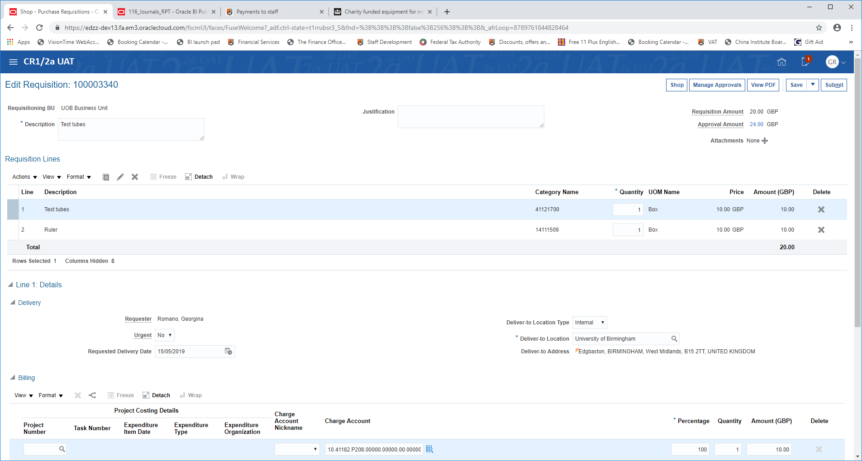
The approval amount will usually show VAT (assuming the item is usually Standard Rated). If the End User considers that the goods or services being purchased are eligible for VAT zero-rating because they are for advertising, then they will scroll down to the following box towards the bottom of the screen;
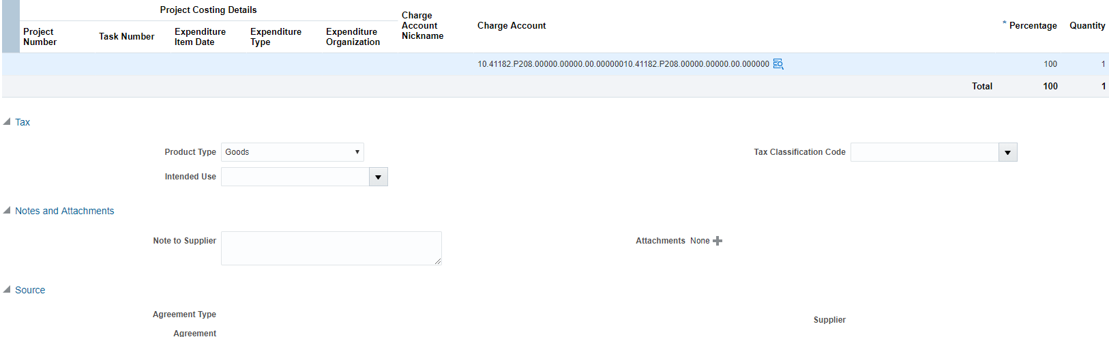
- In the Intended Use drop down box – pick Advertising - External.
- Complete Zero Rate VAT Certificate (available from the Purchasing News on front page of Requisitions screen) by using the writeable PDF boxes including digital signature. Tick 8 or 8A for advertising services and 8B or 8C for the supply of designing or producing an advertisement, or tick one of the other options where appropriate.
- Save and attach the completed Certificate as an attachment to the requisition as shown above. In ‘attachments’ under ‘category’, choose the drop down box ‘To supplier’.
- Go back and click ‘calculate amount with tax’ at the top of the page.

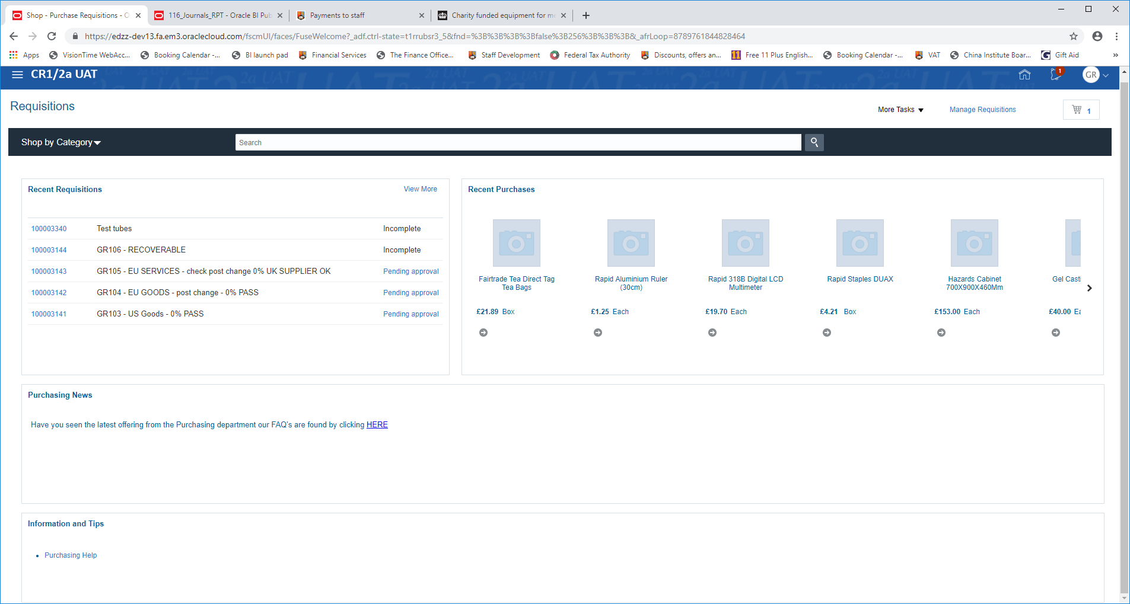
ZERO RATE CERTIFICATES WILL BE AVAILABLE HERE – TO BE COMPLETED AND ATTACHED
Plus Guidance and links to where to go for advice in your College

