Buzz 188 – December/January

Inside
- Celebrating Disability History month 2020
- Supporting our students through self-isolation
- Introducing our new Dubai Provost
- How our researchers are making our diets healthier and tastier

Vice-Chancellor’s View
Watch the latest video recording from the Vice-Chancellor.
Birmingham Literature Festival

As part of our partnership with the Birmingham Literature Festival, the University of Birmingham is sponsoring a podcast with Kit de Waal, a Birmingham born and based author and patron of the 2020 festival. The podcast is available to listen to now.

"We're proud to be in partnership with this wonderful, international literary festival which brings so much to the city's cultural life. It's inspiring to see how the festival has adapted in these times, which can potentially be so isolating - a vital and timely reminder of the central part writing plays in communicating, challenging, consoling, celebrating or holding to account."

Dr Luke Kennard, Reader in Creative Writing and Literary Studies, Department of Film and Creative Writing

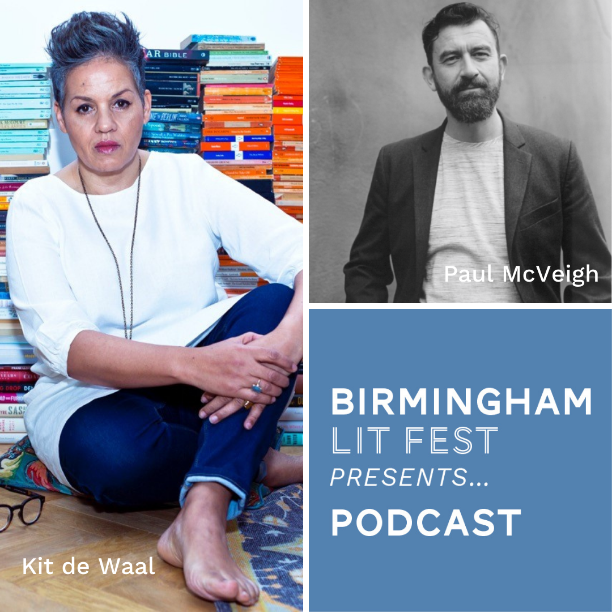

Birmingham 2022
The Commonwealth Games is an international sporting event that unites nations and territories from across the world. Birmingham will host the next Games in the summer of 2022 and we recently announced that the University will be an Official Partner of the Games.
Watch this video of members of our community sharing the exciting news of the partnership.
For staff and students, our collaboration with the Games will provide many valuable research, volunteering and participation opportunities at a major sporting event and will enable the University to play its part in delivering a successful Games for the city and region. Staff and students will also be hoping to demonstrate their sporting abilities by competing in the Games, as they were able to in the 2018 Gold Coast Games.
As part of the partnership, the University has three exclusive research alignments:
- Health and Life Sciences
- Global Challenges
- Energy and Environmental Sustainability
The University’s major partnership with the Birmingham 2022 Commonwealth Games is really exciting for our community because we will be the main campus village hosting athletes from 72 nations and territories in our accommodation. Our role as Official Partner of the Queen's Baton Relay- International Leg will provide opportunities to promote the city and University across the globe. Additionally, the hockey and squash competitions will take place at our world-class sporting facilities, meaning that we will be able to welcome thousands of visitors to our beautiful campus and be seen by an estimated global TV audience of 1.5 billion.

We heard from one of our students, Jake Burkey working at Birmingham 2022.
“Hi everyone! My name is Jake and I’m a Business Management with Marketing student at the University, currently on placement at the Birmingham 2022 Organising Committee. I, like many others, have been excited at the prospect of a home Commonwealth Games since its announcement. I’m a student athlete and I knew that with my academic interests, the business side of sport would be the direction I wanted to go down, so I’m extremely fortunate to have the opportunity to work on such an exciting project. Within the Organising Committee, I’m part of the Venue Management team and I’ve found this such a great position to be in as a student on placement. It’s really allowed me to oversee so many of the operations that take place. I get to work closely with lots of departments and stakeholders, which has been really valuable to improving both my understanding of the organisation, and the personal skills that I think will be valuable going forward in the workplace. All in all, the first seven weeks have been very enjoyable and I feel like I am developing every day as I experience different challenges that I’ve never faced before. I look forward to taking on more responsibility over the next few months, and hopefully bringing the University and the Committee closer together in the future.”
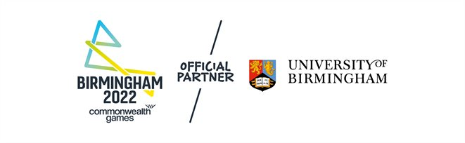
Disability History Month 2020
There are more than 11 million people with a limiting long-term illness, impairment or disability in the UK. On our campuses, one-in-ten students has declared one or more disabilities.
2020 has brought landmark anniversaries in the fight for fairness and equality for people with disabilities in the United Kingdom: the 50th anniversary of the Chronically Sick and Disabled Persons Act (1970), the 25th anniversary of the Disability Discrimination Act (1995) and the tenth anniversary of the Equality Act (2010).

Celebrating Disability History Month at UoB – our inaugural DHM programme
18 November to 18 December is Disability History Month, and the University is exploring the theme of 'Accessibility: How far have we come? How far have we to go?' with a comprehensive programme of events.
With still a few weeks left to run, the programme, which brings together contributors from across our Edgbaston and Dubai campuses, provides an opportunity for everyone in our University community to come together to increase our understanding and to show our support for disability equality. The programme offers opportunities to find out what it means to live with an invisible disability, or how to navigate a career as a disabled person, or what accessibility may look like in a post-COVID-19 world. We’ll be drawing upon expertise and lived experience both locally and internationally to challenge perceptions, shape the debates and explore what accessibility and inclusivity really mean in the 21st century.
Events include:
- Professor Richard Black, UEB champion for disability, leading a panel of academic and professional services staff talking about the impact of their disabilities on their careers in HE, a “human library” for sharing of life stories around living with a (hidden) disability.
- A webinar on enhancing accessibility on campus for students
- Talks by the Department of Disability, Inclusion and Special Needs on autism awareness and disability inclusion
- A showcase of inclusive fitness activities at UBSport
- The Cadbury Research Library looking at the life of Harriet Marines, a prominent deaf woman and author in the 1800s
The full programme listing is available at the Disability History Month website.
What are we doing to make the University of Birmingham accessible for all?
Here are a few examples:
Our Teaching and Learning Building was the first capital project that adopted the “beyond legal compliance for best practice” principle from the Inclusive Design Guide developed by the Estates Office. The teams behind this project have built in additional consideration for neurodiversity, including soundproof quiet rooms, tables with adjustable height to accommodate users with different sensory and mobility requirements, as well as softer lighting, a reduction in reflective surfaces, and colour schemes that are calmer than those of previous designs.
At a time where face coverings are now commonplace in society and mandatory in many spaces on campus, it is important that we support our colleagues and students who are exempt from wearing a face covering due to disability or for reasons where wearing a mask would cause severe distress to the individual. To help staff and students to whom this applies, in September, the University adopted the Hidden Disabilities Sunflower Lanyard scheme, giving staff and students the option to display the sunflower lanyard if they feel that they would benefit from wearing one. The lanyards are designed to signal in a discreet, yet visible way to people around the wearer about support needs or for disability conditions that may not be visible.
HEFi launched the Inclusive Educator Canvas course earlier this summer to support our academics to embed inclusive teaching practices. This will be complemented by Student Services’ new Student Equality Diversity and Inclusion (EDI) Canvas course, which will offer inclusive tips for students, such as how to make PowerPoint presentations dyslexic- and colour-blind-friendly.
Going forward, accessibility will be one of the focuses of the University’s upcoming Equality Scheme 2021-2024. We will think profoundly as a whole institution to ensure that equality, diversity and inclusion is fully embedded in what we do for our students, staff and community – the latter exemplified by Birmingham being host to the International Blind Sport Federation World Games in 2023. We will be welcoming more than 1,000 competitors from over 70 nations at the world’s largest high-level international event for athletes with visual impairments.
You can find out more on the University’s work in this video from the Vice-Chancellor.
Meet our staff who share their experiences of working with a disability and those who are helping make the working environment a more equal place

David Cottam: IT Manager for Research and Education (College of Social Sciences) and Co-Chair of the Enabling Staff Network on why he got involved with the Enabling Staff Network (ESN).

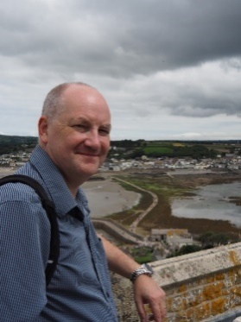
The Enabling Staff Network started as the Staff Disability Group (SDG) and was formed after the 1998 Equality Act. I became involved after I was introduced to the group after being registered blind in 2006.
I have Optic Atrophy of both optic nerves and have very slow progressive sight loss. So slow that I didn’t realise I had lost so much sight over the years until cycling to work one morning along the canal in 2006, I had a near miss with an oncoming cyclist who I did not see. We both managed not to get wet… I then went to the hospital for a check-up and was told I was legally blind.
The first SDG/ESN meeting I attended, the group was looking for someone to Chair. I said if no-one else wanted to do it, I would chair the group for a few months. Fourteen years later, I am now Co-Chair with Paula Douglas.
I have worked for many years in IT Services based in Social Sciences. I have been fortunate as I have access to all the latest technology for visual impairment, some funded by Access to Work (which as individuals we need to make more use of – see the government’s website).
When someone approaches me for advice, I try to use my experience of the disability-related situations and encounters I have had to help others.
ESN has been involved in many projects on campus over the years, both improving accessibility and passing on knowledge of the impact of disability to others.
We have only been able to achieve what we have with the support of many colleagues across the University who have taken on board concerns we have raised and have actively worked to resolve them.

Rachel England: Research Assistant, Department of English Language and Applied Linguistics on her experience during the COVID-19 pandemic.

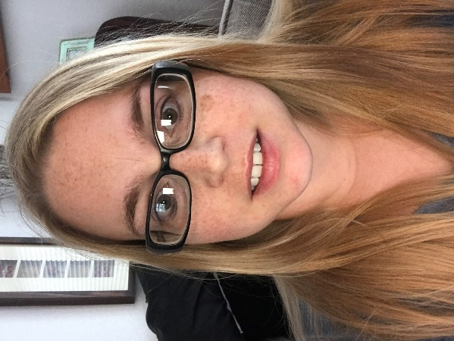

I am a Deaf, non-clinical academic, and new member of staff. Despite the measures put in place for the COVID-19 pandemic, my experiences at department level to date have been positive. My two colleagues both have access to a transparent face visor to wear in replacement of a mask in communal areas when they need to communicate with me. These team members in question are due to start learning Level 3 British Sing Language (BSL) for more ease of communication with me when I have no BSL interpreter working with me.
At institutional level, I was given a pager on my first day that alerts me tactically when there is either an actual or test fire alarm occurring and its exact location. In addition, University staff have been very helpful accommodating any reasonable adjustments, such as allowing me to inform my line manager via text message of my absence in place of a phone call as per their policy.
I also wear my own sunflower lanyard and a badge saying I’m a lip-reader. These alert people that I have a hidden disability and for them to remove their mask whilst social distancing, or write things down to make themselves understood more easily.

Pete Collins: Equality and Diversity Officer for Students on his journey to being diagnosed autistic.
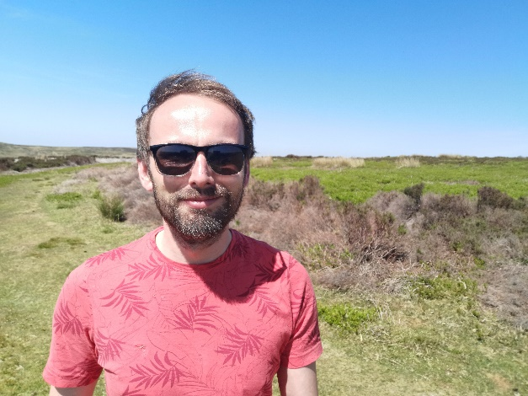

It’s been a strange journey getting to where I am today. I spent the first 34 years of my life not knowing I was disabled. I knew I was ‘different’ compared to most of my contemporaries, but I could never quite work out why I didn’t ‘fit in’. I seemed to view the world in a completely different way to most people, I socialised in a different way, I had different interests. That didn’t do much for me in terms of popularity. I also had some quite significant struggles in terms of my memory, my ability to perform certain tasks, and, inevitably, my mental health. As time went on, and the struggles followed me into my working life – moving from one job to another, never quite finding an environment that was ‘right’ for me – I began a search for answers. This search would lead me to being diagnosed autistic in 2017. That’s when everything began to change.

Sanam Yaqub: Equality, Diversity and Inclusion Lead, Dubai campus on working on EDI in Dubai
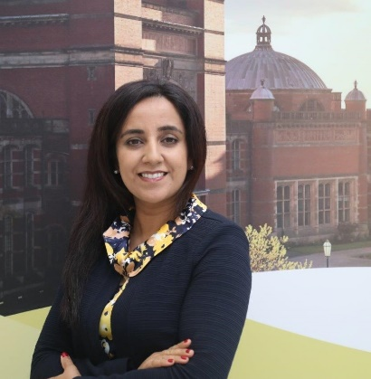
Having lived and worked in the United Arab Emirates for the last 13 years, I have experienced first-hand the positive changes that have influenced and shaped this young and dynamic country. What has been particularly impactful are the priorities that the UAE continues to place on inclusion, tolerance and fairness; values that have underpinned the culture and traditions of the UAE since its inception almost 50 years ago.
Working within this context, I am immensely delighted to have been given the opportunity as the Dubai campus lead for Equality, Diversity and Inclusion. Our culture of inclusivity is central to the University’s core values and indeed is the foundation of our Dubai campus. As a facilitator and enabler of the conversations that evolve and shape this agenda, this role places equality, diversity and inclusion at the core of influencing, decision-making and engagement. In order to create an open, productive and intellectually challenging learning environment, we must continue to foster a diverse and inclusive institutional culture, where everyone feels dignified, valued and free from harassment and bullying.
Our Dubai campus follows the same standards and principles as in Birmingham, where equality is promoted, diversity is valued, and discriminatory behaviour is simply not tolerated. As part of my role, I aim to ensure that we maintain an engaging and creative dialogue between Edgbaston and Dubai – a dialogue that enables us to contribute to wider community engagement. We should also continue to adopt an approach which finds common ground between the values of tolerance and inclusion in Dubai society and our own equal opportunities ethos in fairness and equality. Within this synergy, we maintain to be committed to safeguarding respect, fairness and dignity of all individuals within our global operations. I greatly look forward to working alongside staff and students across the University to ensure that we remain active in managing diversity and addressing challenges which may inhibit us from fulfilling our potential.

Dr Sonali Shah: Burdett Research Fellow, School of Nursing, on her research. Sonali is a British Indian disabled woman.

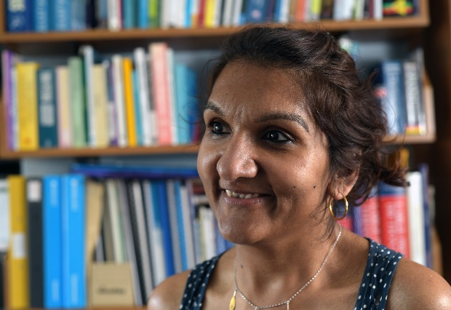
I am a Research Fellow in the School of Nursing. I teach about issues concerned with the global challenges of equality, inclusion, health and social wellbeing of disabled people with intersectional identities and across the life course. I was awarded IAS funding to co-host an interdisciplinary network event on Disability and Life Course research across the University of Birmingham, and on the back of its success I am working with the team on possibilities for a future interdisciplinary network.

I have developed various projects on disability and the life course and use exciting approaches, including theatre and life histories, to engage with a diversity of stakeholders and to bring an awareness of disability and social change to non-academic and young audiences, and to provide a platform for disabled people to have a voice in the development of practices and policies that impact their lives.

As we celebrate the University’s first Disability History Month, we would like to take the opportunity to introduce you to the Enabling Staff Network.
The Enabling Staff Network is for disabled, and non-disabled, members of staff from all areas of University life who have a common goal to raise awareness and to improve facilities for everyone with disabilities. We are supported by HR and have reporting lines to Professor Mark Sterling, the Deputy Pro-Vice-Chancellor for Staffing and Professor Jo Duberley, the Deputy Pro-Vice-Chancellor for Equalities.
When we talk about disability, it is within the terms as defined under the Equality Act 2010. We look at issues that are physical, mental, on the autism spectrum, dyslexia and many more.
A lot of the work we do is raising awareness of issues with the University and actively working with the University to resolve them. This includes physical issues like access to buildings, accessibility administrative process and policy such as Emergency Evacuation Planning, as well as improving awareness and support for mental health.
We are also regularly invited to assess the impact of new projects at the University and within the area, which may affect the local community.
If you have an interest in getting involved, or just want to be added to the ESN mailing list to receive information on issues impacting disability on campus, please email ESN@contacts.bham.ac.uk to be added to the list. ESN also has a Microsoft Teams Site, which you may request access to for general discussion about topics in the field of disabilities.
David Cottam and Paula Douglas,
Co-Chairs Enabling Staff Network.
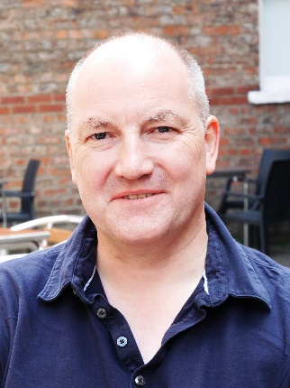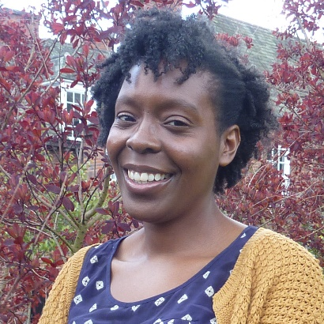

Supporting our students

Many students this academic year have had to self-isolate to keep each other and our community safe. We spoke to Campus Services to get more information on what has been going on behind the scenes with our support for students during this time.
For students who are having to self-isolate, we are providing an enhanced care package to ensure their health, wellbeing and academic needs are supported. Campus Services has been delivering 'We care, you share' boxes as an option for those in quarantine.
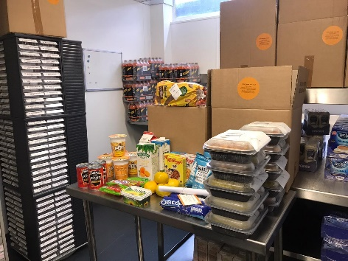As always, we were excited to be welcoming new students onto campus. This year, we knew we needed to plan ahead – including offering support services for students who were required to self-isolate.

The Challenge: food to your front door
Inevitably, some of our students would need to self-isolate in their flats, either after a positive test, as a precaution while waiting for test results, or as quarantine after overseas travel.
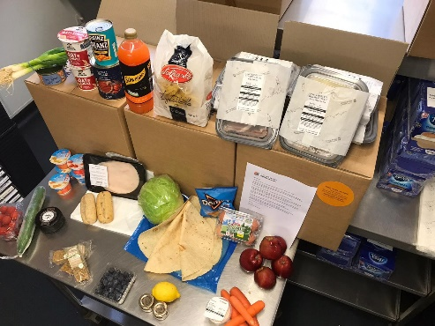

The Solution: an online hub to offer immediate support

All students who were told to self-isolate automatically received a free sharing box of food for their whole flat. These supplies of basics – from bread and milk to fruit, ready meals and snacks – were designed to last for two or three days, giving them time to organise deliveries for the future. Over 90% of students described their free sharing box as helpful, with 73% finding the quality of items good or excellent.

Student feedback on the isolation boxes
‘I think it was prepared perfectly with everything we need.’
‘The box was excellent with a great variety of fresh, frozen and non-perishable food. Thank you very much!’
‘Great! Really happy with the box & very grateful.’
Students on Meal Plan were offered a range of delivery options using their weekly balance, with individual breakfast/lunch and dinner boxes available with freshly made meals inside. Self-catered students were supported with the option to order food too, plus lots of advice on how to set up orders elsewhere.
Everything ran through an online hub, making it easy to find medical advice and practical information at the same time. The team also provided a wealth of wellbeing and mental health support online, plus support with things like links to a discounted laundry collection service.

How we did it: plan ahead, use what’s already in place, adapt
Campus Services teams from Catering and Conferences & Events began working on support plans from July, as the teams knew many international students would need isolation support. This meant services for self-isolating students were already in place and working well from before term began, and simply needed to scale-up as demand for more meals increased.
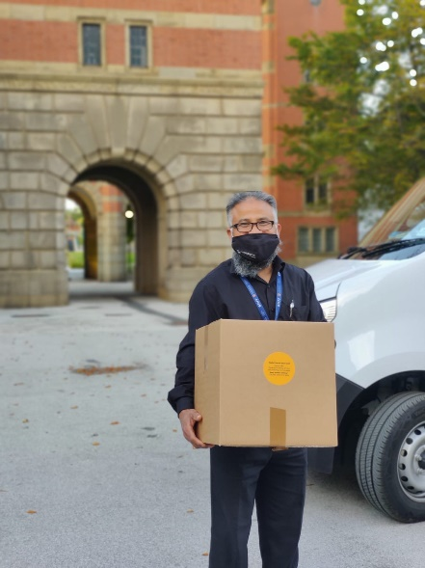
As Sarah Clayton from the Conferences & Events team explains, ‘We wanted to provide the best level of care we possibly could, especially as many students would be living away from home for the first time. The whole team was happy to be able to help. We shared menus and options online, and processed all the bookings and deliveries. We were proud to be offering that practical support, and to know our students were being looked after.’
Drivers who usually provide delivered catering services for meetings across campus became a food and essentials delivery service for the students. With a fleet of vans and a team ready to go, it was possible to provide same-day meal deliveries if students requested them before 3.00pm.
‘It was great to be able to help,’ says driver Jashim Ahmed. ‘With online orders, we were able to get the boxes out all day, with non-contact deliveries and a really safe way to help students keep indoors.’

We spoke to one student, Jay, who was able to share his experiences of lockdown and the support he received.

“I’m studying law, and I’m in my fourth year. I was disappointed to learn that I would have to isolate, but understood why, given how serious infection rates were. As a house, we first discussed isolation and how we would deal with things if one of us became infected, around two weeks before it happened to us. We sat down and agreed that we’d carry on living life as normal within the house, and deal with what would come together, regardless of how many of us actually might end up with the virus.

From my college, I was supported with a personal phone call from Wellbeing to check if I had access to food, was staying in touch with friends and family over FaceTime, and whether I could carry on with uni work from home. I also dropped into a Zoom session to discuss my experiences with others in isolation, and hear more about how the Arts & Law team could help.

The worst thing about self-isolating has to be the repetition and inability to exercise! As a runner, I train multiple times a week and also spend a lot of time in the gym, so being unable to do this was an unwelcome shock to the system. As a house, we really struggled with the boredom of isolation - we were really quite good at making sure we all spent time together in our kitchen and would often arrange drinks nights and movie nights to keep things as normal as we could. I wouldn’t really say there was a best thing about isolation - other than knowing that whoever tested positive would have a chance of having immunity, and that we were doing our bit to stop the spread of the virus.

I’d say to anyone realising they have to isolate to immediately chat with who you’re living with about how you’re all going to deal with it. Of course, it is the law to isolate for the specified time as an entire house, but it can become far more like normality - albeit with the front door permanently closed - if you all deal with things together. And listen to your body - the tiredness can be a huge surprise, so make sure you rest as much as you can to ensure you recover as well as possible”.

Research in Focus: How are our researchers making our diets healthier and tastier?

Did you know the University is home to the largest Chemical Engineering-based food research group in the UK? Its work focuses on food formulation - a new method of food science - and it is conducting groundbreaking research into the structure of foods, flavour delivery and food hygiene.

By developing new formulation engineering methods and techniques, the team is creating cutting-edge and novel approaches to food processing and the development of healthier, higher performance products.

They are developing engineering techniques to produce low-fat and low-calorie chocolate, and reduce salt in products such as cheese and sauces. This work, carried out in partnership with leading companies, both informs and responds to industry demand for healthier alternatives to conventional food products.

It has been fundamental in enabling industry to develop processes, such as controlling and manipulating fat crystals at the point oil and water meet, and to produce zero-fat spreads, which are stable in storage but break down when consumed to give the physical properties and flavour release expected from margarine.

Recently, an enhanced understanding of the molecular events occurring during fluid gel formation has allowed the production of small, spherical and reasonably soft particles that resemble oil droplets, and research on the physical chemistry and microstructure of shell formation around oil droplets has reduced the hidden fat in foods.

Work on fat-reduced emulsions has led to patented technology for both chocolate and bakery fats, while research into engineering processes and the better understanding of the physics of particles involved in the segregation of sugars and water or salt and water has led to a technique to allow significant salt reduction in snacks.

Find out more at the formulation engineering website and watch the video.

Chancellor’s Column

Three of the most important factors that will enable us to beat the coronavirus and get to the other side of the pandemic are the availability of vaccines, therapeutics that will prevent the sad deaths from the virus and enable the widespread implementation of mass rapid antigen testing.

At the time of writing this, we have had joyous news from Pfizer/BioNTech that their vaccine has proven to be 90% effective in preventing people from getting the virus. The UK Vaccine taskforce has already procured hundreds of millions of doses of a range of vaccines under development worldwide, including the Pfizer/BioNTech, as well as the Oxford/AstraZeneca vaccine. I am confident that by the end of 2020, these vaccines should start to get implemented and by the first quarter of 2021, the priority list of 20 million people in our country should have been vaccinated, with the rest to follow.

With therapeutics, we already have dexamethasone, which has shown to reduce deaths by one-third in patients on ventilators and one-fifth in other patients receiving oxygen only. Hopefully, it is only a matter of time before there are more existing drugs/a combination of existing drugs/new drugs that may cut the risk of death by up to 80%. And, we have had the good news in November that the pilots for rapid regular affordable mass antigen testing have started in Liverpool and are being rolled out across the country. These tests will be a game-changer in identifying asymptomatic individuals, who if they test positive, will be then confirmed with a laboratory PCR test and thereafter asked to isolate, while the rest carry on. Just imagine, when we as a university will have access to these tests, so that our whole university community – our students, staff and faculty can all be tested regularly - allowing our university to operate, firing on all cylinders, as close to normality as possible. I now genuinely can see the light at the end of the tunnel!

What has not ceased to amaze and impress me is how our university has gone the extra mile this year. A sterling example is the third exhibition of the exciting annual collaboration between the Royal Collection and the Barber Institute of Fine Arts, with our MA Art History and Curating students staging an online exhibition, “Sights of Wonder: Photographs from the 1862 Royal Tour”, with amazing photographs of Albert Edward, Prince of Wales, on his four-month journey through Egypt, the Holy Land, and Greece. It is of course, serendipitous that the Prince of Wales as future King Edward VII opened the University of Birmingham in 1909, with that historic photograph of him in our Great Hall.

It is during times of crisis when major initiatives can emanate – there is no better example than the Beveridge Report published in 1942 and implemented after WW2 – an initiative that changed the history of this country with the formation of the Welfare State and the National Health Service. An example of this in the current crisis is the publication in July of the “Net-Zero: The Road to Low Carbon Heat” report published by the CBI and University of Birmingham joint Heat Commission. The report highlights the challenges of decarbonising heat – heat is the largest source of carbon emissions in the UK, accounting for more than one-third. The commission, chaired by Professor Martin Freer, Director, Birmingham Energy Institute and by me, in my role as President of the CBI, makes several important recommendations to assist the government in shaping the policy framework and raising awareness to business of the benefits of decarbonising heat. The report demonstrates clearly that without addressing this issue the government will not achieve its target of net-zero by 2050. The report has been extremely well received both by the media and by the government, leading to three meetings with the energy minister, Kwasi Kwarteng

Once again, the University of Birmingham is leading the way in one of the most crucial areas for the future of our planet.

Dubai Campus Developments

The University’s Dubai Campus recently welcomed its new Provost, Professor David Sadler.

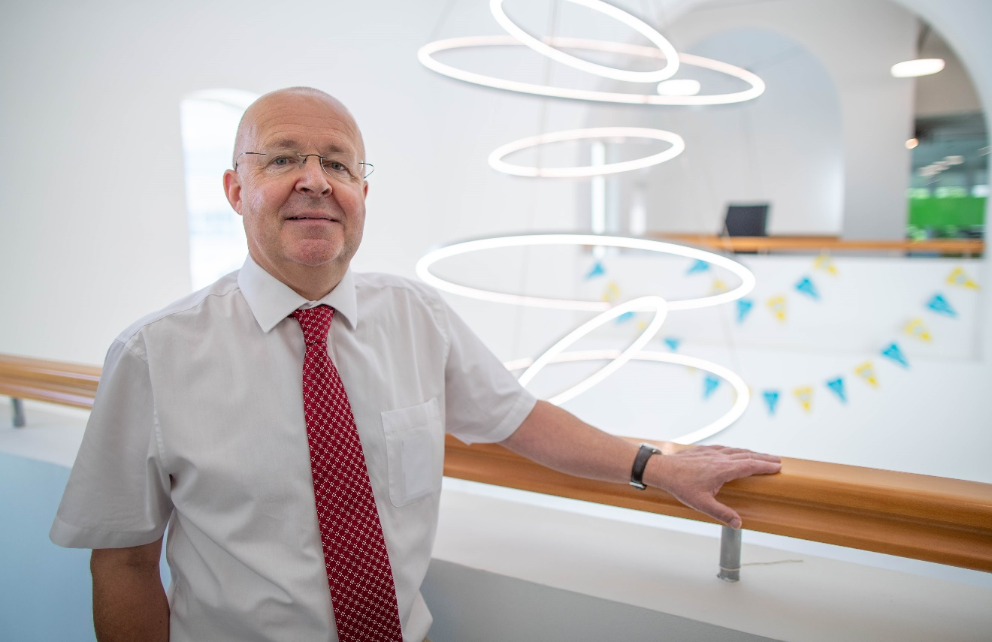

“I’m delighted to be joining the University of Birmingham in Dubai at such an exciting time in its development. After two full years of operation, we are well-placed to take the next steps towards realising a longer-term ambition of becoming the leading international branch campus in the UAE. There’s a lot of work to be done, and many challenges, but the campus team is well connected with many layers of support from Edgbaston, and it’s incredibly energetic and agile. Together, I’m confident we can continue to grow and develop into a fully rounded campus environment”.

Progress on the new campus building continues apace, with over 1,200 construction workers now based on the site. A milestone of more than 1 million hours without significant accident or injury was celebrated recently. The main structure is clearly taking shape.
Multiple ongoing strands of work are linking together planning for Phase 2 in areas as diverse as staffing, furniture, laboratory equipment and student activity spaces. Campus Director Ben Bailey has visited the building site more than any other member of staff, to the point where he’s now regarded as an accredited part of the Edgbaston Estates team. Speaking after his most recent site visit, Ben said, “I’m impressed by the speed, the quality and the attention to site and worker safety. The project is well on schedule and the building is going to be an impressive and tangible statement of our commitment to the highest possible standards in all that we do at the Birmingham Dubai campus.”
Strategy for the Dubai campus is overseen by a Steering Group, which meets monthly, and at its most recent meeting approved an exciting additional suite of programmes to deliver for the first time from Dubai in 2021/22, to ensure we take maximum advantage of the new facilities. As the project develops, the aim is to create an environment that has the additional capacity to build research bridges between the UK and the UAE, and to develop a portfolio of executive education and professional development courses.
The Dubai campus is also contributing more widely within its regional environment, with pro-bono activities being explored by the School of Law, strong networks already established with local schools and internship opportunities for Masters students amongst recent highlights. There’s also the prospect of Expo 2020, still called that despite being deferred to October 2021 –April 2022 due to COVID-19, where the Dubai campus is expecting to make several distinct and lasting contributions. “I’m particularly keen to ensure that the Dubai campus plays a role within its setting that reflects the University of Birmingham’s strong civic traditions”, said Professor Sadler.
Watch the latest drone video of progress in Dubai.

MyUoB App - extending the student digital experience
MyUoB, the University’s new official mobile app for undergraduate and postgraduate taught students, launched just before the beginning of the semester. Within the first month, MyUoB received an incredible 30,000 downloads, which really demonstrates the demand from students for accessing key information via this platform. It brings a number of key University services and resources together in one place for the first time ever, providing students with convenient access to relevant information, wherever and whenever they need it, whilst studying here at Birmingham.
What are the features of MyUoB for students?
- Access to the latest news updates and COVID-19 guidance
- View personal timetables
- Find and request library resources
- Access up-to-date module information in Canvas
- Receive notifications about seminars, lectures and assignments
- View emails and Outlook calendar
- Use the map to navigate around campus
The app also has a customisable dashboard, which allows students to move their favourite features around so that the services and resources they use most are quick and easy to find.
MyUoB has been a collaboration between Student Services, IT Services and Collabco, a company specialising in digital platforms for higher education. Feedback from students has helped steer the development and the focus has very much been on been improving the student digital experience by simplifying the way they access information such as personal timetables and library information. MyUoB integrates a number of different University systems such as Alma, Primo and Canvas as well as Outlook into one single platform that delivers an easy and engaging way for students to interact with University resources.
Jules Singh, Education Officer at the Guild of Students, said, “I’m excited to see how UoB students can make the most of the app. It’s changed the way they receive information and I hope it will be of great benefit to the UoB community for many years.”
MyUoB is available as a mobile app and as a web app for use on laptops and tablets. In the first 30 days since launch, the app has been downloaded over 30,000 times and has had half a million unique visits. There have been 2.5 million requests for timetables and 4.7 million interactions with app content.
For now, the app is only available for undergraduate and postgraduate taught students, but there are plans for a release for postgraduate research students in the near future. A mobile app product team has been established with the responsibility of guiding its success and defining new features to improve it. Initially, this will focus on student content and managing the day-to-day development. The app itself has an inbuilt feedback form which allows students to inform any future developments. Additional future releases in the pipeline include creating additional dashboards for Dubai, applicants, alumni and staff.
The MyUoB app is free to download from the Apple store and Google Play and is available online at myuob.bham.ac.uk.

