Images of Research 2020/21

Submission guidance in practice

Below we highlight some recent entries to Images of Research that demonstrate some of the key guidance advice particularly well. The entries are separated into two headings – images taken directly from research data, findings or of the subject of the research and then images which have been created by the researcher to represent their research.

Please note, the submission requirements and guidance have been updated from previous years. Although you are encouraged to review the examples below and previous exhibition booklets, please keep these potential changes in mind and refer to the submission requirements and guidance for the 2020/21 competition requirements.

Images of Research: data, findings or subjects

- Charlotte has used a CT scan as her image entry.
- The recognisable subject matter intrigues the viewer to find out what animal the skull belongs to and the contrast of black and white with pops of bright colours is visually appealing.
- The narrative links to the image effectively and makes the importance of the research very clear.

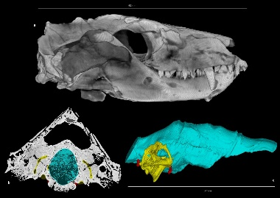 | Charlotte Bird - College of Life and Environmental Sciences
 | Virtual Palaeontology: Peering inside the skull
 | Virtual palaeontology is pioneering the non-destructive study of fossils. As a researcher, I use CT scans to peer inside the skulls of extinct organisms and digitally reconstruct their anatomical features. This skull belongs to a cynodont (a, UCMP 40466), part of the evolutionary lineage leading to mammals. Through masking cavities (b), 3D models of the brain, inner ear and neurovascular anatomy (c) allow brain evolution in cynodonts to be assessed, with calculations of sensory capabilities and intelligence levels indicating behavioural patterns. Importantly, I will also investigate the bias in digital reconstruction techniques, an issue of multidisciplinary importance.

- David’s entry is a high resolution, well composed photo of a grey-haired eastern chimpanzee.
- The title is particularly effective – cleverly tying the research subject and research focus together.
- The narrative poses a number of questions that engage the viewer and leaves them wanting to know more. You can easily imagine if David were present at an exhibition the audience would be intrigued to know more about his findings so far.
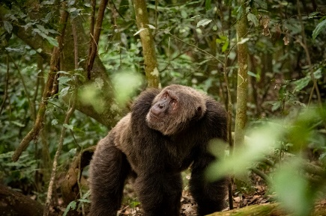 | David Pettifer – College of Life and Environmental Sciences
 | The Grey Man of the Forest
 | Lanjo is a strong, healthy, grey haired eastern chimpanzee in the prime of his life. Despite his colouration, he is only 21 years old, and expected to live another 10 years on average. But what about those individuals who survive beyond this, reaching the upper limits of their lifespan? Does a chimpanzee at the age of 50 experience the same suite of old-age complaints as a human might? My research focusses on changes in mobility and joint health as chimpanzees age in the wild and captivity. I aim to understand how environment and activity may affect the health of these individuals, particularly as they move forward into their twilight years.

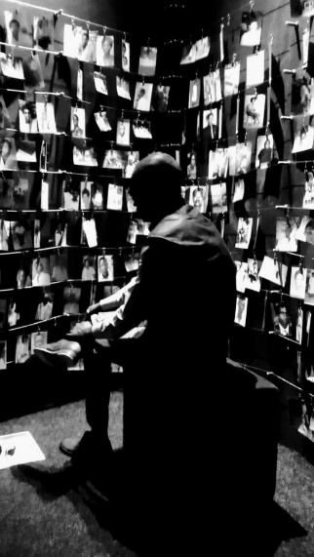 | Jeannette Rodgers – College of Social Sciences
 | Out of the Shadows: the case for the participation of children in transitional justice.
 | This image shows a young man at the Kigali Genocide Memorial in Rwanda, looking intently at exhibited photographs of the many victims of the genocide in 1994. I took this photograph whilst visiting Rwanda in April 2019 – a year marking 25 years since the genocide. Children under 18 in Rwanda are known as ‘Generation 25,’ and my research makes the case for how, and why, the participation of these children should be integral to the purpose of international, national and local justice. The project seeks to understand their perspectives on what the meaningful participation of children should look like, to inform a new framework of participation in law and development.
- Jeannette submitted a striking black and white image, with effective use of light and shadow.
- This is particularly effective as the title uses the language of shadows and the image narrative explains the research problem as increasing participation – children being seen.

- Zakareya entered a compelling image which was a ‘scanning electron microscope image with a layered energy dispersive x-ray elements map’
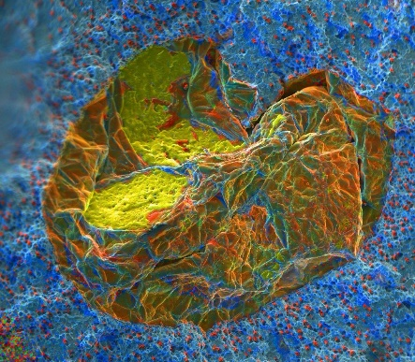 | Zakareya Nashwan - College of Engineering and Physical Sciences
 | Ductile Cast Iron Rainbow Defect
 | Ductile cast irons are used in several critical components across many applications like automotive, railway, energy generation and aerospace. Failure during service of these components could be catastrophic. Double oxide biofilms are defects found hidden inside casted metal components that reduces mechanical properties significantly leading to premature failure. A scanning electron microscope image with a layered energy dispersive x-ray elements map is revealing the first observed double oxide bifilm on a fracture surface of ductile cast iron test bar. The image shows the complexity of the defect as each colour of the spectrum represents an element.

Images that are representations of research

- Ahmed’s image is compelling as it is unexpected, well balanced and has repeated colours from a select palette.
- Ahmed does a great job of weaving the image, title and narrative together through his choice of language – shown in bold.
- This is a creative example of how you can engage an audience with your research without using a literal image of data, findings or research subject.
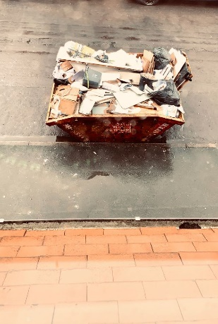 | Ahmed Saad - College of Arts and Law
 | Modernity: Is it all a load of rubbish?
 | This photo is of a skip full of rubbish from a refurbishment process of a bathroom. My research focuses on traditionalist Muslim response to the challenge of modernity. Studies of Muslim responses either neglect this response or misidentify it. They focus on responses that assimilate or dismiss modernity altogether. Traditionalist response does not see modernity as something to assimilate to or neglect; it avoids a binary way of thinking and looks beyond the dictates of leave it or bin it. Engaging this response can change our evaluation of tradition and ability to explore recycling some of its components.

- Ruby uses research data as the inspiration for this image but has creatively composed the images to be reminiscent of pop-art
- Although the mice do form a part of the research itself, this demonstrates how you can focus on a specific element of your research process, creatively making it more visually appealing in a digital collage.
- Ruby has a strong title which provides clear direction to the aim of her image, which is confirmed in her narrative.
- Ruby’s entry is particularly engaging as it explores a potentially controversial topic – animal testing. Providing an insight that may challenge the viewers own point of view.
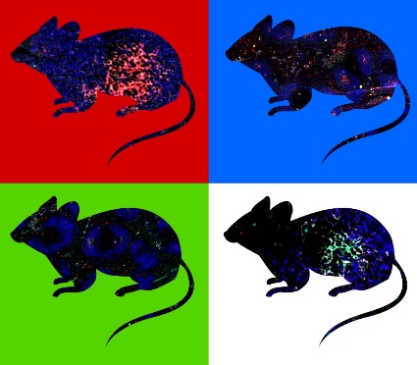 | Ruby Persaud - College of Medical and Dental Sciences
 | Gatekeepers to research
 | Animals have played an integral role in providing breakthrough treatments and medication. What most fail to understand about this research is the humility and respect it takes to work with them. My PhD research uses mice to investigate the immune system, and how vaccines protect against invasive Salmonella infection, a leading cause of morbidity and mortality worldwide. Without mice, we would not be able to achieve the research required for making effective vaccines that protect current and future generations. This piece is in dedication to the animals that make my work possible. The images you see are from imaging experiments that show individual cells in immune organs.

- Natasha manages to capture her research effectively with this bold one word title.
- Natasha’s entry shows a pot of tea being poured for two in an image that has been composed by the researcher as a representation of the research themes.
- The image narrative is very effective in demonstrating how this image and title relates to their research.
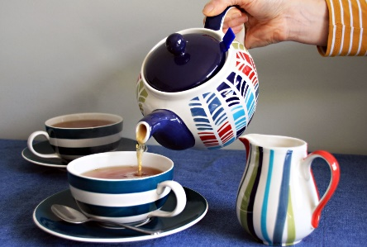 | Natasha Nicholls - College of Social Sciences
 | Welcome
 | The UK Community Sponsorship Scheme empowers volunteer groups to resettle and support a refugee family into their local community. They provide a warm welcome to a family in need, meeting them at the airport and providing financial, practical and emotional support as the family adjusts to their new life. Tea is a universal symbol of welcome; sharing a cup of tea is informal and offers comfort. It is likely to have been shared between the volunteers during the planning stages, as well as being offered to the family once they have arrived in the community. My research focuses on the motivations of the volunteers, why do they get involved?

